|  |
| --- |
| COMPUTER CONTROL SYSTEM  FOR  **Desmet Ballestra S.p.A.**  ***SABIZ PLANT***  JOB 2F11  OPERATOR MANUAL |
| *T.I.E. s.r.l.*  *Caronno Pertusella (VA) – Italy*  Revision 0 – July 2012 |

# General Concepts

This Manual is divided into two parts:

* The first one, the most important, determines the system architecture as both the hardware and the software aspects; in particular it will be specified how data are organized and how they are exchanged among PCs.
* The second part defines the functions implemented in the Computer Control System.

# First Part

## System architecture and general concepts

The system consists of 3 PC performing the Peer to Peer functions. Physically the plant dislocation is like the drawing below.

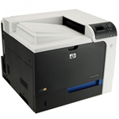

**PC1**

Operator

workstation

**PC2**

Operator

workstation

**PC3**

Operator

workstation

**HP1**

Colour printer

Ethernet 1000 Mbps

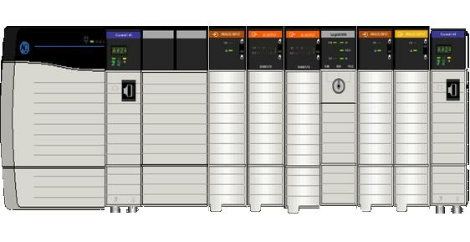

**Rack 0**

ControlLogix

**Rack 1**

ControlLogix

**Rack 2**

ControlLogix

ControlNet

*192.168.10.1*

*192.168.10.2*

*192.168.10.3*

*192.168.10.101*

*192.168.10.51*

**All data are stored on the PC**.

The PC also stores the Raw Material Definitions, the Accumulators and Recipe files.

The Application can view and modify the data and download recipes. In the same way all the automatics reports foreseen are printed out on the color laser printer.

On each PC are present the applications: Lgw2F11.

From the Windows main menu 1 icons will be provided. The operator will start the application, by clicking the relevant icon.

## Hardware/software technical features of PCs

Each PC will have the following technical features :

- DELL PRECISION T3500

* CPU Intel Xeon W3530, 2.80GHz, 8M Cache
* 4GB Memory, DDR3, 1066MHz
* 2 x 320GB, SATA, 3.5-inch, 7.2K RPM Hard Drive, RAID Level 1
* 1 16X DVD+/-RW Drive with SATA Cable
* 1 Controller Gigabit Ethernet Broadcom® 5761 (integrated).
* 1 additional Gigabit Ethernet Broadcom card
* 1 Microsoft Office Home & Business 2010 software / license
* 1 LogoView NT software / license
* 1 RSLinx Classic OEM Software / license

The following hardware, connected to every PC, will also be supplied:

* 1 Dell Standard Quietkey USB Keyboard Black US International
* 1 Dell Black 2 Button USB Optical Mouse
* 1 Dell E-series E2210 22" Wide Monitor - Black

Moreover also these items complete the SABIZ supply:

- 1 Colour laser printer HP CP4025N

- 1 Ethernet switch CISCO SLM2016T 16 ports Gigabit

- 1 RSLogix 5000 software / license (installed only on PC1)

- 1 Simantec pcAnywhere (installed only on PC1)

## Data Organization

Data managed by CCS can be divided into the following classes, according to the type and functionality:

1. database for internal use only of the LogoView application (format “dbf” e “txt”);
2. database managed by the LogoView application but having the purpose of historical filing and therefore with reading possibility through other tools (format “dbf”);
3. file of “RAW\_MATERIAL\_DEFINITION” (format “xls”);
4. files of “RECIPE” (format “xls”);

### Data Type “A”

**“dbloop.dbf**”; this results to be a univocal-type file whose functions are exclusively of internal use of LogoView application software; any manipulation and/or reading of this file is absolutely forbidden .

“**dbanl.dbf**”; this results to be a univocal-type file whose functions are exclusively of internal use of LogoView application software; any manipulation and/or reading of this file is absolutely forbidden .

**“DBRMDOS.dbf”**,**“DBRMPB.dbf”**; this results to be a univocal-type file whose functions are exclusively of internal use of LogoView application software; any manipulation and/or reading of this file is absolutely forbidden .

### Data Type “B”

**“alarm.dbf”**; this results to be a univocal-type file whose function is the filing of all the alarms and/or the machine logging commands .

Data visualisation is possible through a suitable key from operator interface ; there is a limit of 100000 record and the storing is managed in circular mode .

LogoView automatically manages this file which must never be opened and re-saved , above all during the operator station running; for any manipulation it is anyway possible to make a copy (in another folder or in another machine) and to process the file with tools like Excel.

This file is stored in the application folder.

**“htrend.dbf”**; this results to be a univocal-type file whose function is the filing of analogic variables for the visualisation of historical trends during the present month.

Data visualisation is possible through suitable key from operator interface.

This file is stored in D:\HTREND

**“hbatch.dbf”**; LogoView stores in this univocal file the Dosex batch weights for a maximum of 700 batch.

This file is stored in D:\HBATCH

### Data Type “C”

**““Raw\_Material\_Definition.xls”**; it will be possible to have access to it through function key from application that will start the Microsoft Excel package present in the machine.

After the setting of necessary data the operator will use the save-function of Excel without changing the file name that must always be the one indicated.

### Data Type “D”

**Recipes (DX-PB)**; *T.I.E.*, together with *Ballestra*, will supply the recipe master file. Files that will be progressively created by the enabled operator through the Microsoft Excel package will also be in “xls” format and a name can be chosen for them (which will be the RECIPE code).

So, also in this case it will be possible to have access to the recipe files through function key from station that will start the Microsoft Excel package present in the machine.

The system will automatically point at the Recipes folder, and at that point it will be the operator’s duty, guided by suitable names, to choose the subsequent folders up to the opening of the file in question.

In general there is no limit in the creation of recipe files (the only physical limit is the space on the Hard disk), even if, as a matter of fact, from the process point of view, with the introduction of the “RECIPE I.D.“ number limited from 1 to 100, it is obvious that is possible to create only 100 recipes max.

## Folder Definition On The Pc

In this chapter it is indicated the structure of folders present in the PC where files/data described above will be stored (the letter in brackets indicates the type of files that are present).

**All these files stand on the folder D:\DATA that is shared with the name DATA. The PCs use this logic name for approaching it; in this way we are not obliged to use a particular, definite disk (D: or E: etc…) that so could quietly replaced without modifying the LogoView program.**

So **DATA = D:\DATA** if it is addressed by the PC.

And **PC..\D:\DATA** if it is addressed by the other PC.

**2F11 PLANT**

**DATA\2F11\CONFIG\** DBANL.DBF (A)

DBLOOP.DBF (A)

DBRMDOS.DBF (A)

DBRMPB.DBF (A)

DBRECPB.DBF (A)

DBRECDOS.DBF (A)

RAW\_MATERIAL\_DEFINITION.XLS (C)

**APPLICATION FOLDER** ALARMS.DBF (B)

ANALOG.ARC (B)

**D:\HTREND**  HTREND.DBF (B)

**D:\HBATCH** HBATCH\_A.DBF (B)

**DATA\2F11\DOC\**

**DATA\2F11\RECIPE\** 2F11\_DX\_PB.XLS (D)

## Management Of Production Files

The system supplied by *T.I.E.* will provide a suitable program for searching and processing production files automatically created and stored on the PC in an appropriate folder.

In particular three Microsoft Excel applications will be supplied; it will be loaded and configured on the PCs.

Excel software will also be configured/programmed so that starting the appropriate program it will be possible to visualize production data .

On the PC, having anyway LogoView licences/software necessary for the operations described up to now, it will therefore be possible to monitor data relative to the production files.

# Second Part

## System Functions

In this specific job, LogoView NT supervisor system includes 3 personal computers as Peer to Peer and a PLC, performing command functions, monitoring and plant reporting.

The PCs are connected via Ethernet with a PLC Allen Bradley CONTROL LOGIX.

Main functions assigned to PLC level are:

* digital signals acquisition;
* analog channels acquisition;
* management command/state for motors and valves;
* direct control of PID regulation loops;
* current alarms management;
* management of sequences to start/stop production;
* production control according to actual recipe;
* communication to upper level (PC) of information for monitoring and plant control.

Main functions of LogoView NT system are:

* plant supervision
* manual commands
* regulation loops
* current alarms management
* alarm historical archives
* trends (actual and historical)
* recipes management
* plant parameters management
* production reports
* alarms logging

## Startup Procedure

1. Check that PLC is ON and in RUN mode.
2. Check that the Ethernet cables from PC to PLC are connected (via Ethernet switch).
3. Check that PCs cables are connected and that also the HP printer on network is present and switched on.
4. START the **APPLICATION** clicking the icon “LogoView RunTime” on the desktop.

## Shutdown Procedure

**Only ADMINISTRATOR can turn off the computer.**

**Never turn off the computer without having carried out the shutdown procedure.**

1. Close the **APPLICATION** by clicking ALT-F4 (obviously it’s necessary to login as ADMINISTRATOR).
2. Once application is closed, the computer can be turner off.

# Application

At system start-up, into a system configuration screen, a window called “**Waiting for alarms synchronization**” is shown.

The alarm synchronization in the network is fundamental for the system.

When the application starts it will appear a string that put it in wait of linking with all Run application, because the real synchronism will happen at the start of every application (but of closing window written above).

The first video page displays the list of Data base to be loaded.

All data contained in configuration Data Base are loaded in memory to improve system performances during normal work.

## Overview

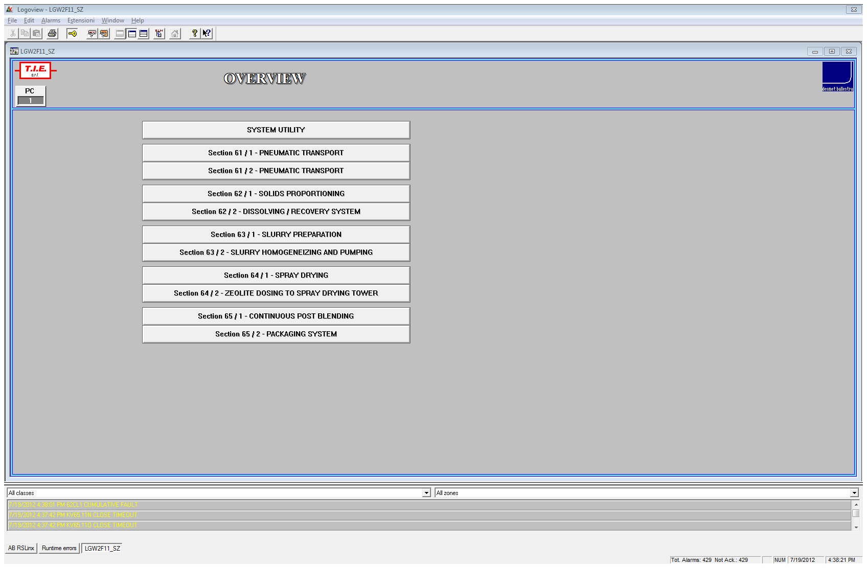

* **SYSTEM UTILITY**
  + **DIGITAL ALARMS MANAGEMENT**
  + **LOOP DEVIATION ALARMS MANAGEMENT**
  + **ANALOG ALARMS MANAGEMENT**
  + **MOTORS/VALVES ALARMS MANAGEMENT**
  + **ANALOG MANAGENENT**
  + **LOOPS MANAGEMENT**
  + **TIMERS MANAGEMENT**
  + **PLANT REPORT**
  + **DOSING UNIT PARAMETERS**
  + **RAW MATERIAL DEFINITION**
  + **DOSEX RECIPE TOTALIZERS**
  + **POST BLENDING RECIPE TOTALIZERS**
  + **POST BLENDING ACCUMULATORS**
* **Section 61 / 1 PNEUMATIC TRANSPORT**
* **Section 61 / 2 PNEUMATIC TRANSPORT**
* **Section 62 / 1 SOLID PROPORTIONING**
* **Section 62 / 2 DISSOLVING/RECOVERY SYSTEM**
* **Section 63 / 1 SLURRY PREPARATION**
* **Section 63 / 2 HOMOGENEIZING AND PUMPING**
* **Section 64 / 1 SPRAY DRYING**
* **Section 64 / 2 ZEOLITE DOSING TO SPRAY DRYING TOWER**
* **Section 65 / 1 CONTINUOUS POST BLENDING**
* **Section 65 / 2 PACKAGING SYSTEM**

Each function can be recalled simply by clicking with the mouse on the relative buttons.

At the left top of the page the number of PC (1-2-3….) is always indicated.

## Password Management

The password management will be based on the “logging” concept of “User”.

**Before working on the system it is necessary to login.**

For approaching to this function, push the button in the toolbar:



Four levels of “User” have been foreseen, the **OPERATOR**, the **TECHNICIAN**, the **ENGINEER**, and the **ADMINISTRATOR**.

Really, to simplify the plant control/monitoring, for the **OPERATOR** level it is not necessary the “login”; this level is enabled to use the following functions:

* start/stop/reset motor
* open/close/reset valve
* set single analog output
* change SP, output, manual/automatic/recipe for PID
* loop trend of PID
* actual trends
* historical trends
* actual alarms
* historical alarms
* plant report request
* view of recipe totalizers

The **TECHNICIAN** has to do the “login” and then he will be able to use the following functions:

* PID setup
* Direct/inverse command for PID
* digital alarms configuration
* loop deviation alarms configuration
* analog alarms configuration
* logging configuration
* motor/valve alarms configuration
* plant parameters configuration
* raw material definition
* recipes configuration
* sequence commands
* Accumulators management

The **ENGINEER** has to do the “login” and then he will be able to use the following functions:

* analog data configuration
* loop data configuration

The **ADMINISTRATOR** is enabled to approach every function.

Besides he can operate on the system after **having closed the LogoView application by pressing ALT-F4**.

In consideration of this important work, for the ADMINISTRATOR it is foreseen another manual for the system management named “SYSTEM ADMINISTRATOR”.

## Monitoring Sections

Each monitoring page related to a plant section, presents in a schematic way all the elements controlled by PLC (motors, valves, etc.).

Graphic representation of the state is made with different colours on the symbols of each element.

The colours of different elements on a video page are as follows:

***Motors***

WHITE Stopped

GREEN Started

FLASHING RED Alarm

LOCK SYMBOL Interlock active

***Valves***

WHITE Closed

FLASHING GREEN Moving

GREEN Opened

FLASHING RED Alarm

LOCK SYMBOL Interlock active

Moreover, the video displays all the analog values, the state of digital alarms and main parameters, related to regulation loop (tag, state, set-point, process value, etc.).

The analog value is in real time displayed on the graphic scheme inside a window, containing also measure unit and actual state related to possible associated alarm ranges.

The state of each analog value is displayed by the different colouring of the window background, that changes when the value is out of alarm limits:

GREY Value within limits

FLASHING RED Unacknowledged alarm

RED Acknowledged alarm

**NOTE**: for some time-delayed alarms, the fore color of the alarm becomes ORANGE when alarm is present, but the related timer is not yet started.

The operator can recall one of the sections in which the plant is divided, striking the associated key in the Overview window.

From each section video page, the following general choices are possible:

* return to overview page
* section pages scroll
* current alarm management
* regulation loop
* manual commands
* actual trends
* historical trends
* historical alarms
* recipe management

### Section 61 / 1

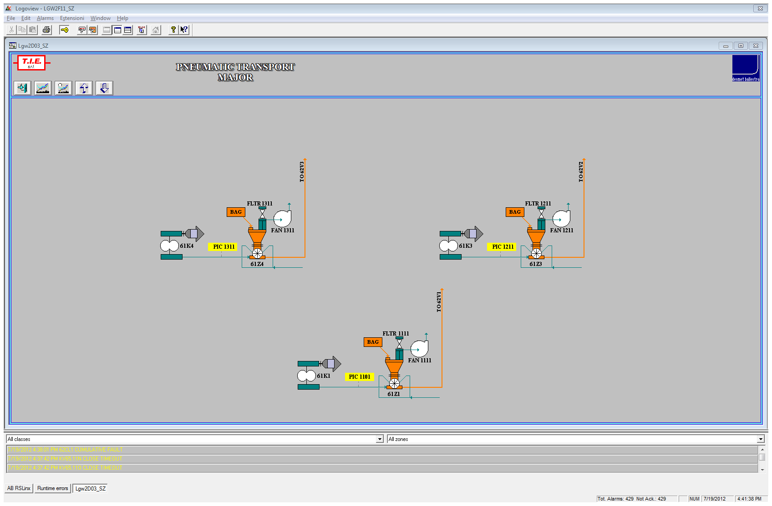

### Section 61 / 2

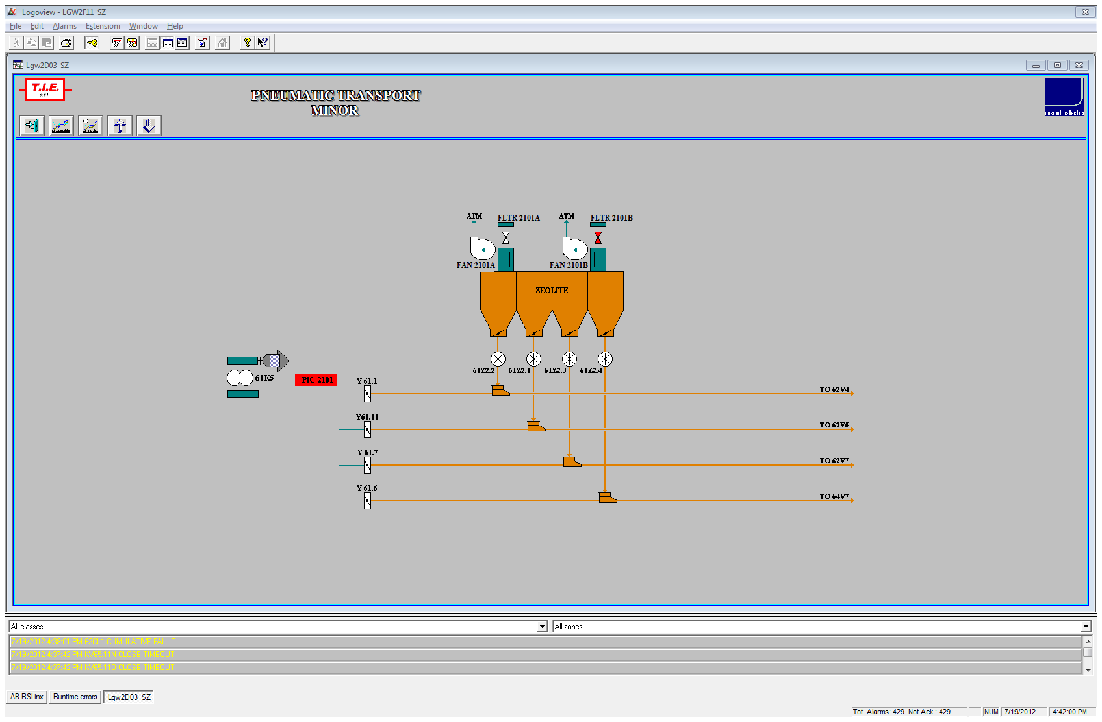

### Section 62 / 1

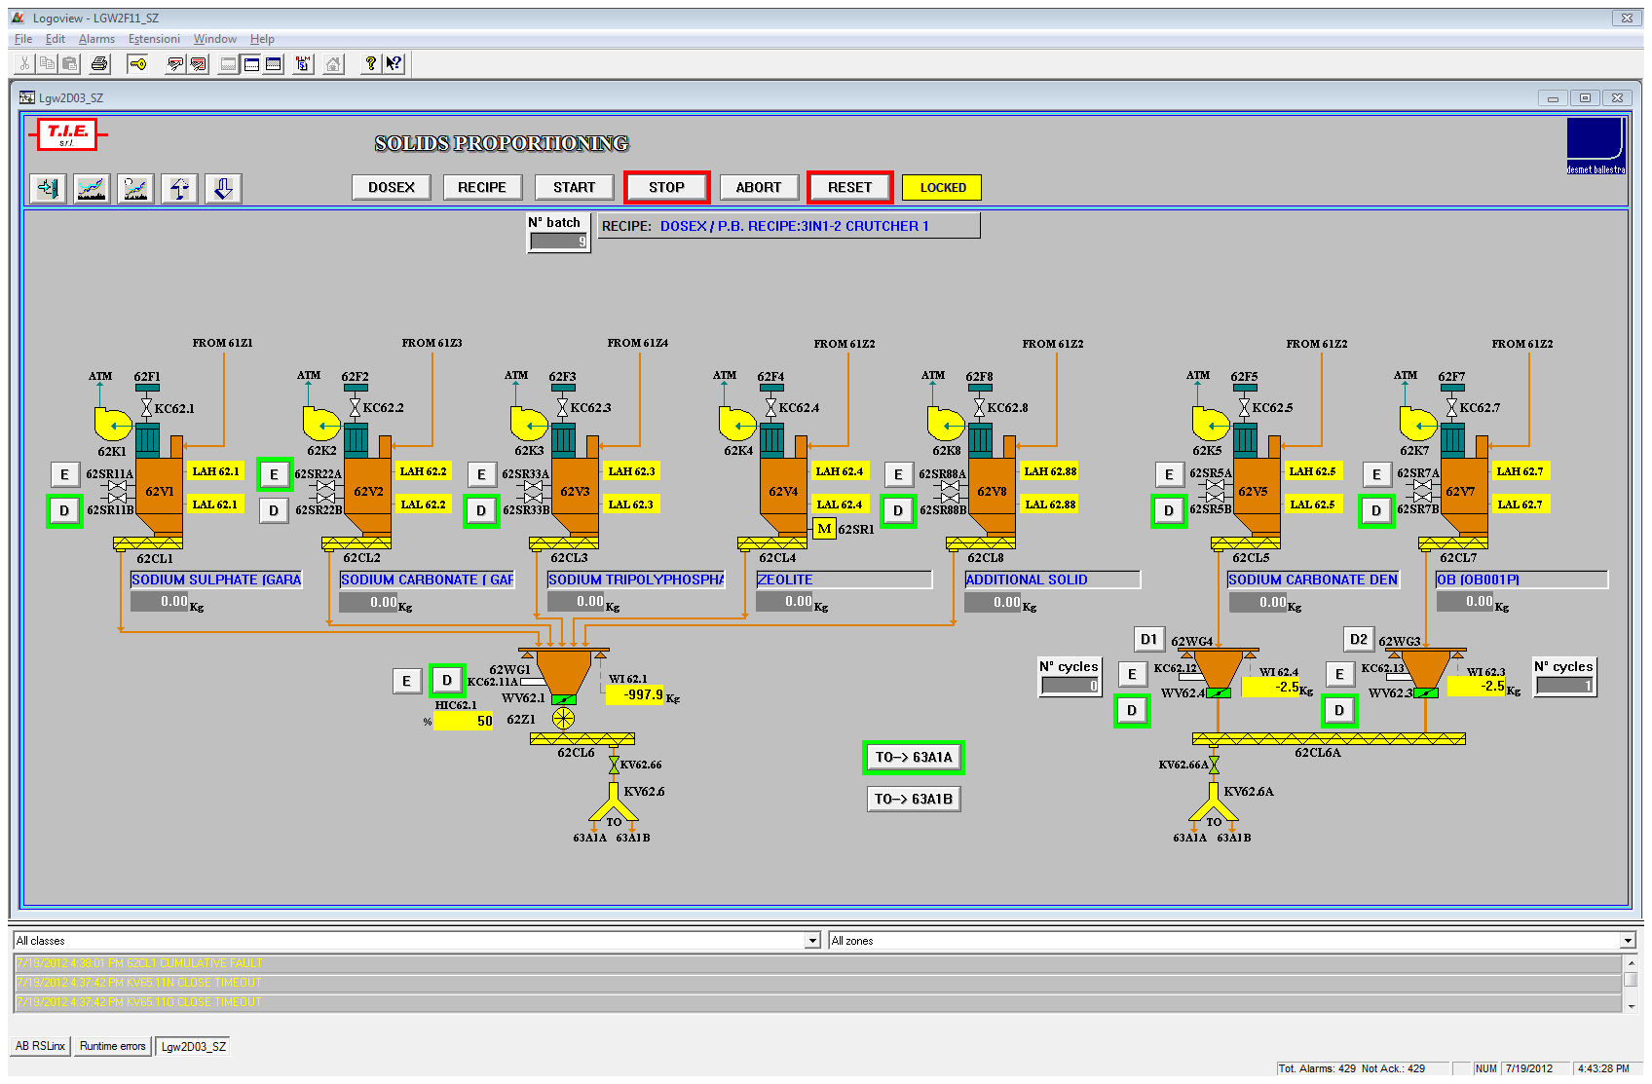

### Section 62 / 2

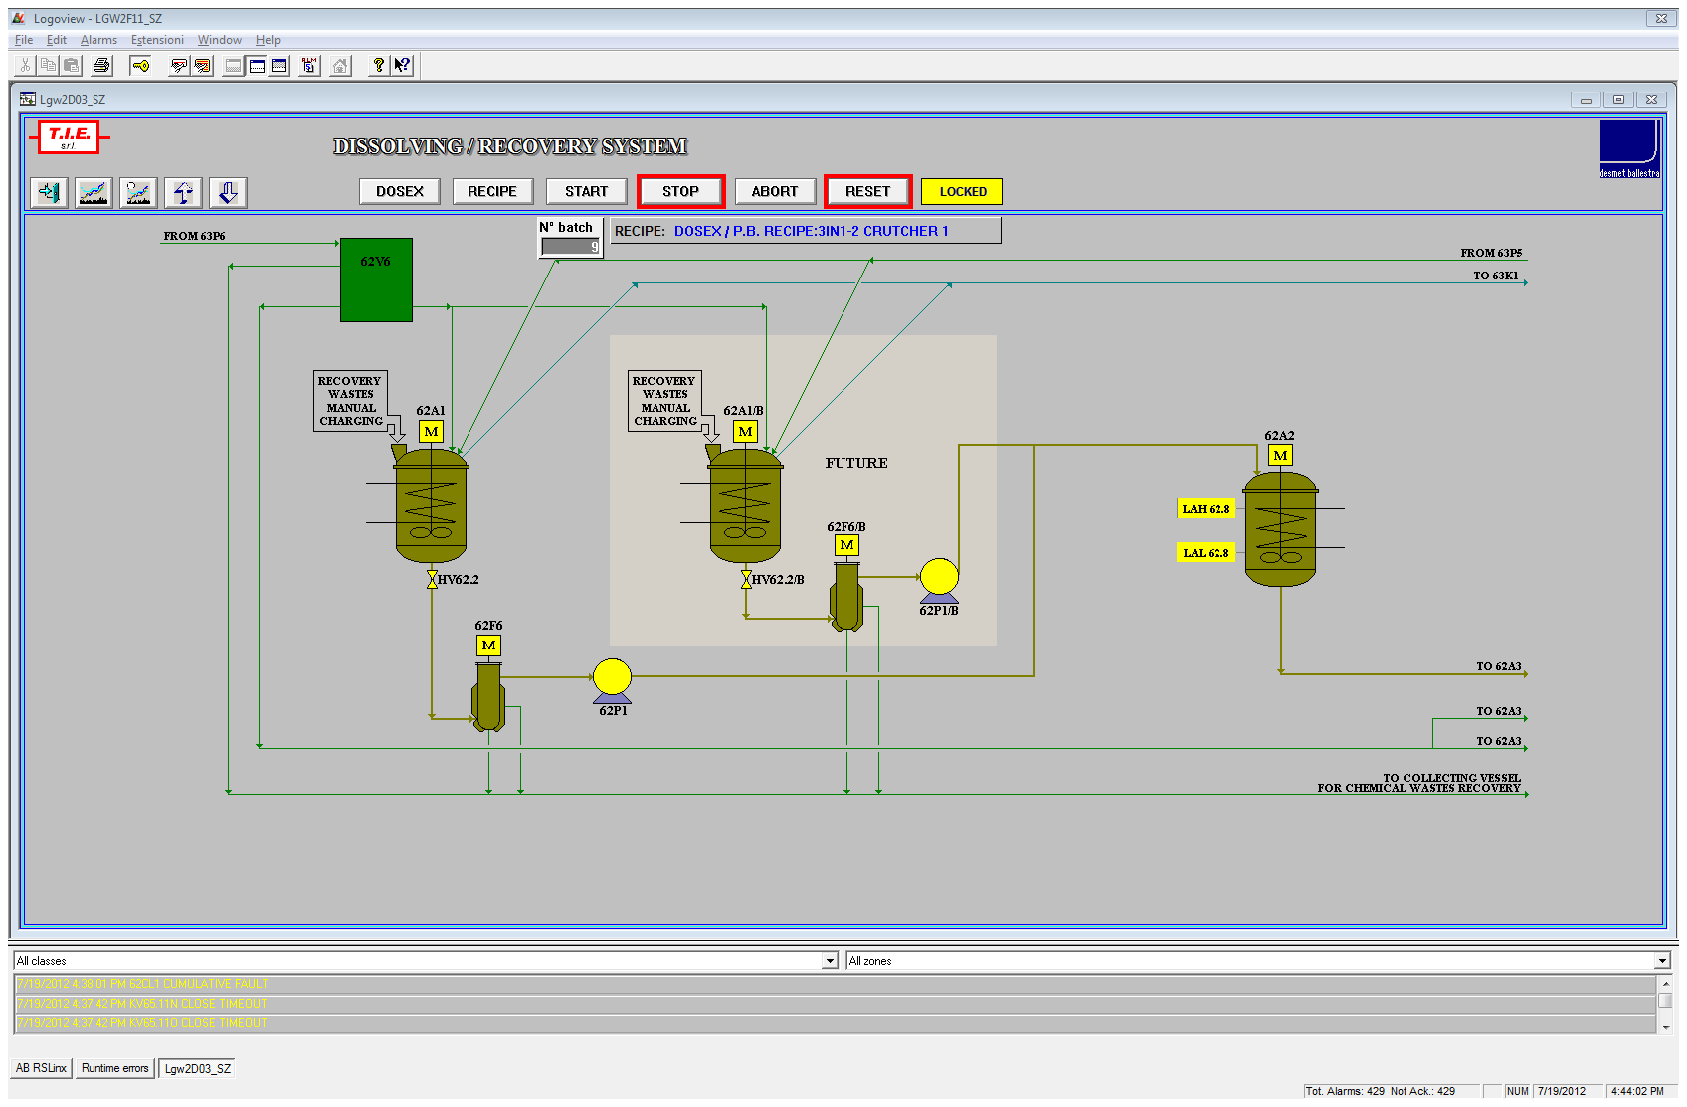

### Section 63 / 1

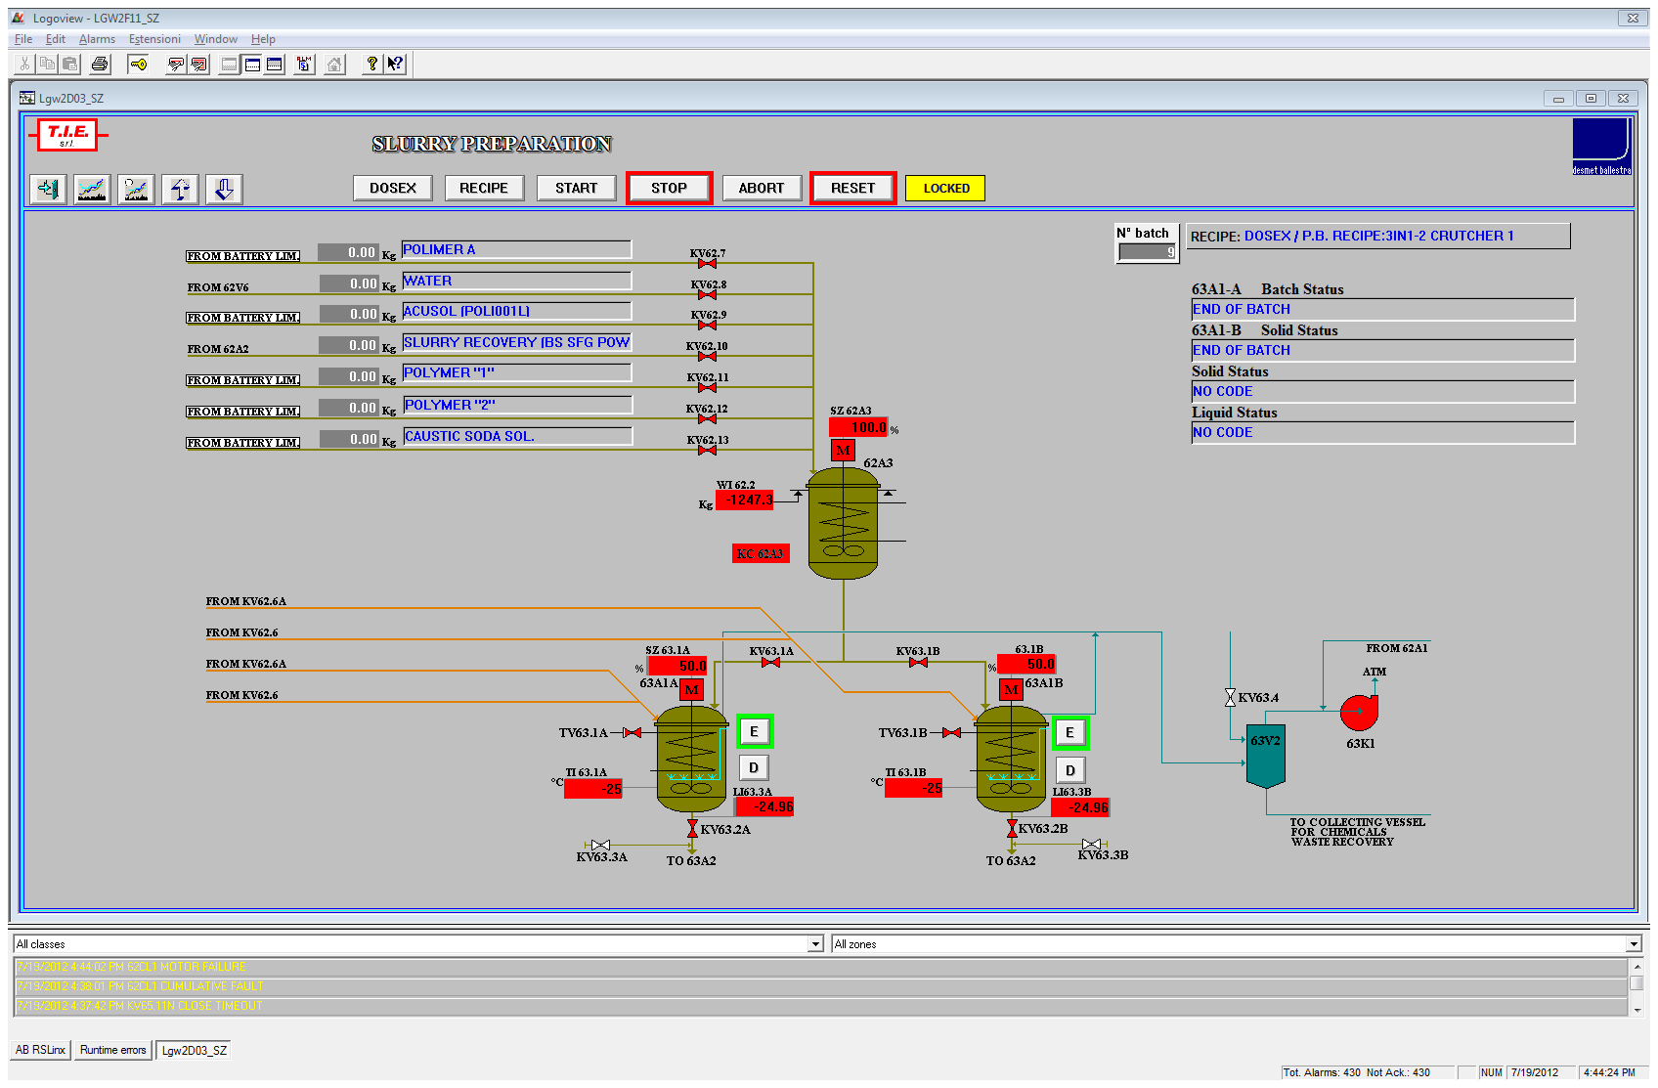

### Section 63 / 2

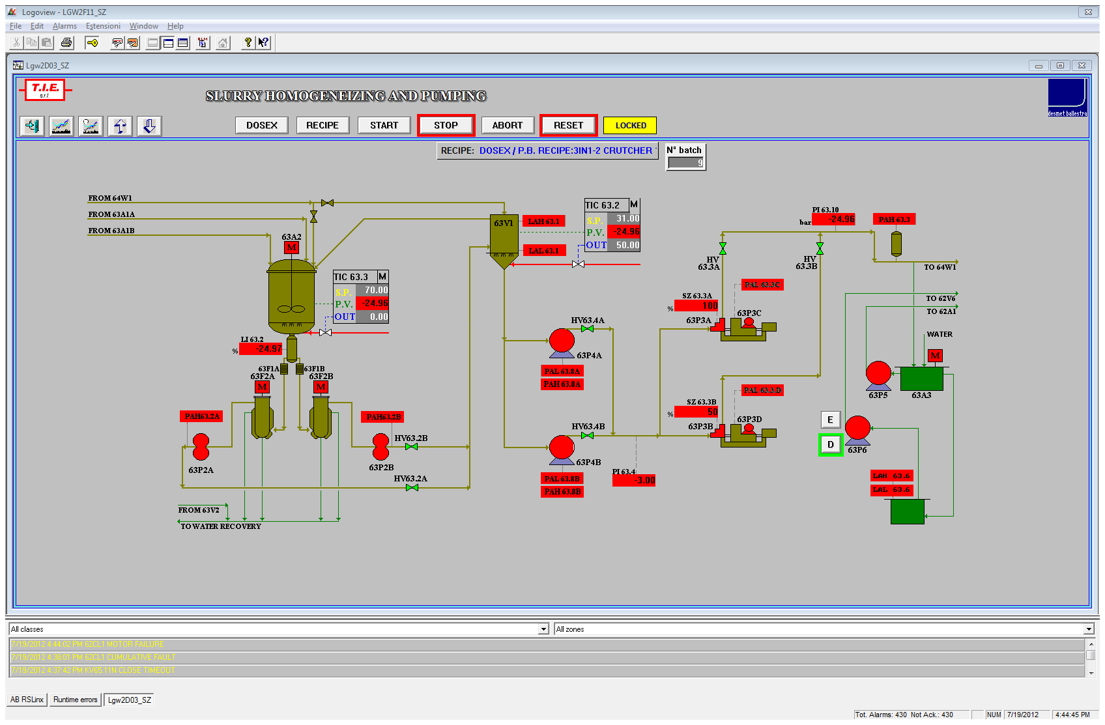

### Section 64 / 1

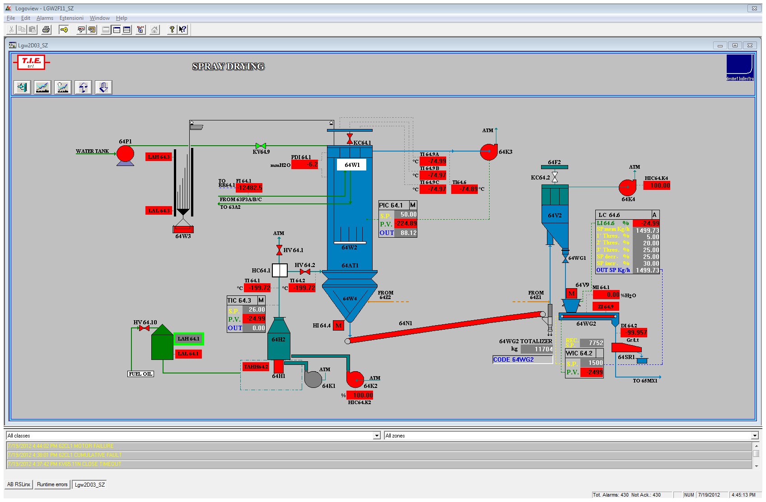

### Section 64 / 2

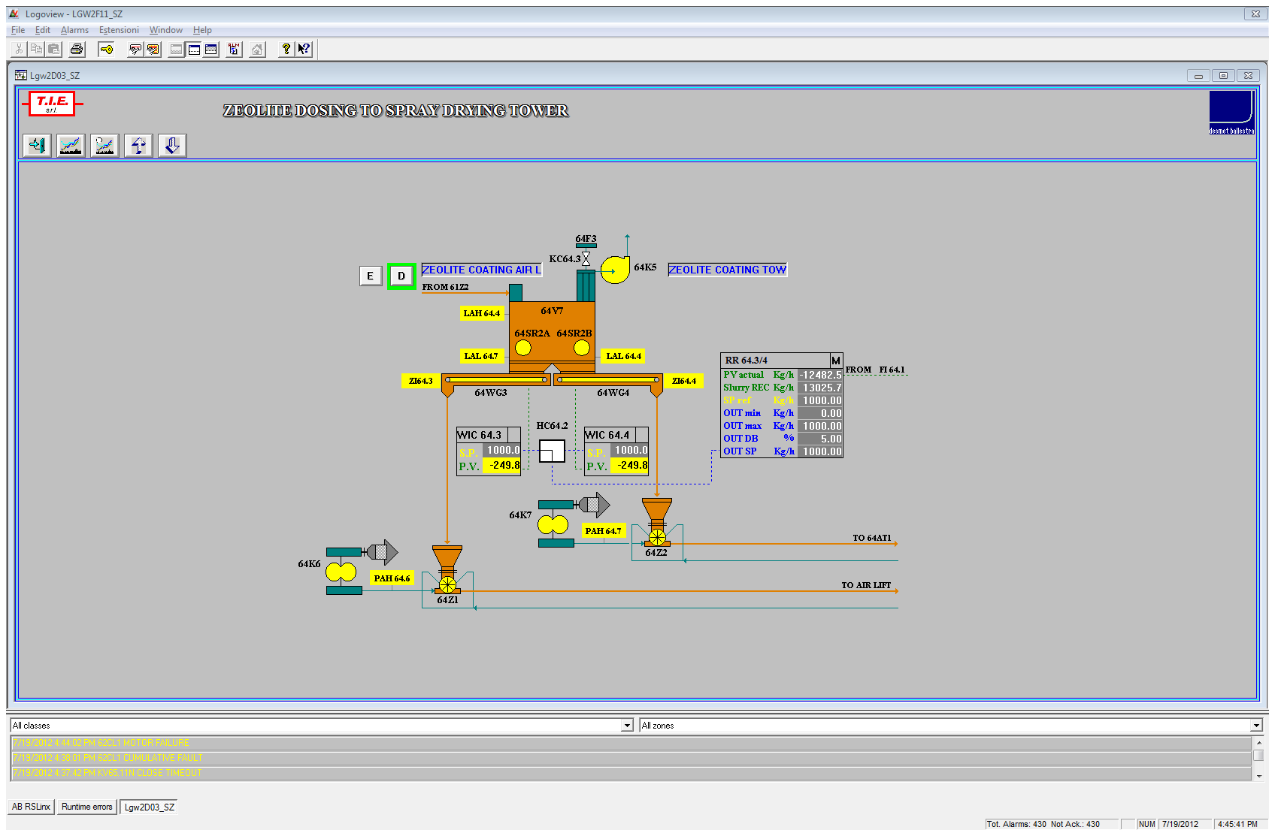

### Section 65 / 1

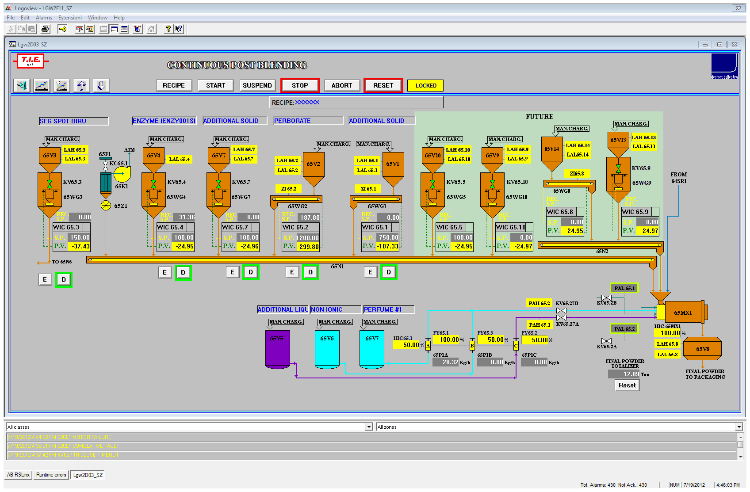

### Section 65 / 2

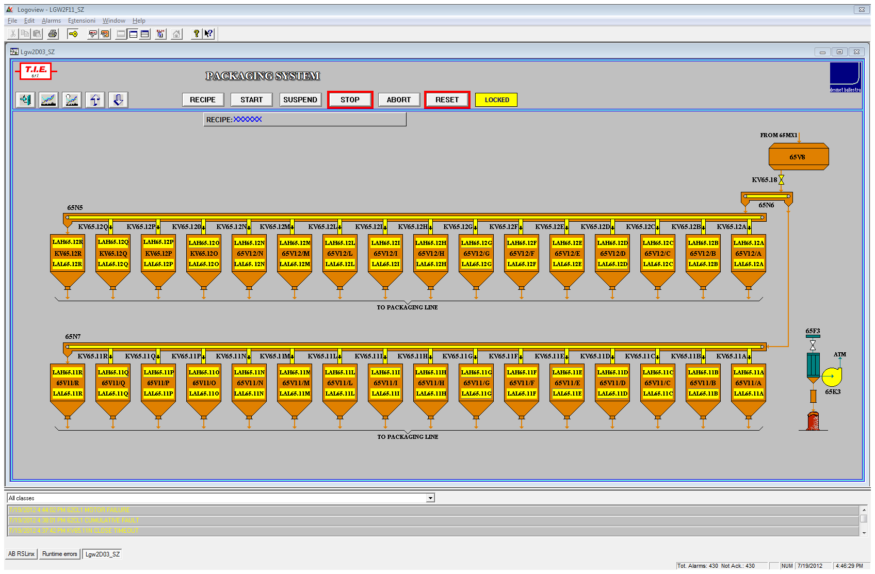

## Manual Commands

Manual commands management pop-up menu can be recalled from monitoring layout pointing on the selected item with mouse and then pressing the **right mouse button**.

When the element has been selected, the video displays a pop-up menu containing the element tag escription and the representation of the enabled function keys.

Following pictures show an example of the different types of windows.

Motor:

fsscr022

_fsscr027Valve:

Selector:

_fsscr025

_fsscr023

PID mode:

The function keys displayed on the window are only those enabled for the selected element.

The command keys normally enabled are:

* **OPEN** Valve opening
* **CLOSE** Valve closing
* **START** Motor start
* **STOP** Motor stop
* **RESET** Alarm reset
* **MANUAL** Set pid in manual mode
* **AUTOMATIC** Set pid in automatic mode
* **RECIPE** Set pid in recipe mode

This system always asks for a confirmation for every kind of command, with a proper window. Only after this confirmation, this command is sent to PLC. Every time that an element changes its state, the related colour will be updated and displayed on section mimic.

## Control Loops Management

From any monitoring page containing control loops, it is possible to act directly on set-point or output of the represented regulators.

The cursor must be positioned on the value that has to be modified; then, clicking this value, the system asks to introduce the new desired value.

When the operator confirms the introduced value, the system checks its validity and, if it is right, updates the value on the regulation loop parameters; in case of wrong value, the system displays again the old one, then the operator can leave the input or retry for another input.

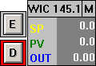

Left click to open “Loop” window

Left click to enable/ disable deviation alarm

**Right** click to cenge loop mode window

For some loops, there are two buttons (**E, D**) used to enable and disble the deviation alarm.

### Loop Window

By positioning the cursor on the tag description of the loop and clicking it, the operator can access to the **”loop window”** of selected loop.

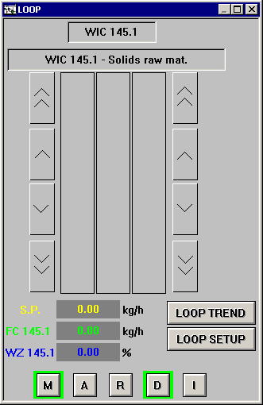

In this window are displayed the following parameters:

* regulator tag with extensive description
* set point
* actual value of process variable
* actual value on commanded analog output
* actual command/state (**Manual-Automatic-Recipe**)
  + Manual: the operator directly commands the output variable value excluding control loop; set point variable can be also modified
  + Automatic: this mode enables the automatic control loop with manual introduction of the set point
  + Recipe: this mode enables the automatic control loop with a set point related to the last download recipe.
* loop operative mode (**Direct-Inverse**)

Set point, process variable, output value, are displayed both in numeric mode and in graphic mode (through bar graph).

The operator can modify the regulator command state taking it to one of the foreseen states pushing the related key (**M, A, R, D, I**) or positioning the cursor on the key representation.

Set-point (in manual and automatic mode) and output (only in manual mode) can also be modified with cursor action on increase/decrease buttons represented on sides of the bar graph; there are two different increase/decrease steps to obtain two different variation speeds of commanded value.

The confirmation of introduction/modification value determines the data transmission to PLC.

### fsscr030Loop Setup Window

In another window, pushing the **setup button**, the following parameters are displayed :

* maximum set value for set point
* minimum set value for set point
* maximum set value for commanded output
* minimum set value for commanded output
* actual value of proportional parameter (P)
* actual value of integral parameter (I)
* actual value of derivative parameter (D)
* actual value of positive deviation threshold (%)
* actual value of negative deviation threshold (%)
* actual value of delay time for the deviation alarm intervention (sec)

The input of discrete values that operator can change (set-point, out, S.P. limits, out limits, PID parameters, deviation thresholds and delay) is made by cursor positioning on the value to modify; the system allows the operation compatibly with regulator work state and the foreseen limits for the selected parameter.

### Loop Trend Window

Pushing the **loop trend** button it is possible to display the line trend of Set-Point, Process value, Output and deviations.

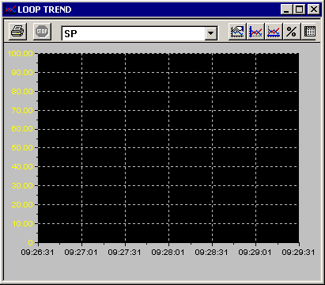

## Alarms Management

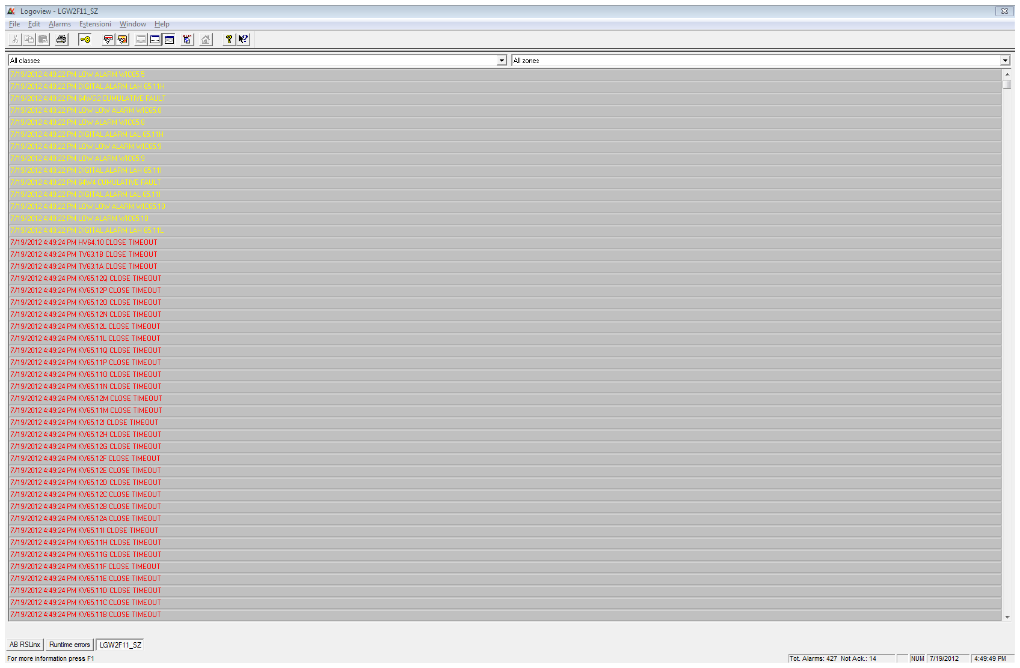

In addition to descriptions of anomaly situations (displayed in section pages), the operator can display a list of all the alarms presently active on the plant.

Any video page can recall the alarms management page by pushing **Ctrl+1, Ctrl+2, Ctrl+3** keys or the following buttons:

Ctrl+1 key removes the alarms page (in the last LogoView version this function is disabled);

Ctrl+2 key displays only one alarm;

Ctrl+3 key displays alarms full page.

The scroll on the next or previous page will be performed using **PgUp** and **PgDn** keys.

The alarm page will be automatically refreshed when the system detects a variation on the displayed situation.

The strings describing alarms have different colours based on the following criteria:

**BLINKING YELLOW/RED** Unacknowledged alarm

**RED** Acknowledged alarm

The acknowledgement function of all alarms is used to avoid that an anomaly disappears without having been noticed by the operator; an alarm disappears only if previously acknowledged by the operator.

After operator acknowledgement, the message disappears only if the alarm has previously recovered; for motors and valves the alarms must also be directly reset on the element in anomaly, as described into the "manual commands" section.

In the active alarms page, it is possible to select a particular alarm pointing on the describing string and pushing the left key of the mouse or the **Enter** key.

The selected alarm is circled with a rectangle of the same colour of the alarm.

The acknowledgement operation can be made in two modes:

**Single alarm acknowledgement:**

double click on the alarm or push the button

**Global alarm acknowledgement:**

push the button

Each event related to alarms (occurrence, acknowledgement or recovery) is stored on hard disk.

## Historical Alarms Management

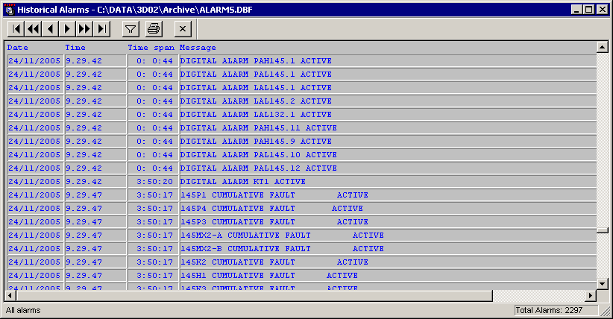

The system has archives that store date, time and description of all alarms that occurred, that are acknowledged and that are recovered on the plant.

These archives store also events logging (change of state for motors, valves, PID, change of PID parameters…).

Data are recorded on a file on disk containing max 100000 information; when the file reaches this dimension, oldest data are overwritten by new information.

For approaching to these data, push the button on the toolbar:

Each string contains the date and time in which the alarm has occurred, the duration, the alarm description and the associated action (active, acknowledged, recovered).

The visualization order is in chronological mode.

With **PgUp** and **PgDn** keys it is possible to scroll previous or following pages, if any.

Going into the page, the alarms visualization will always start from the first to the last one recorded.

At the top of the page there is a bar command so composed:



Previous page

First page

Previous record

Next record

Next page

Last page

Filter alarms

Print alarms

Close page

## Actual trends

Actual trend pages are recalled from any section layout by pressing the relative button:



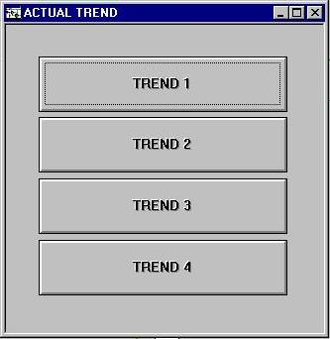

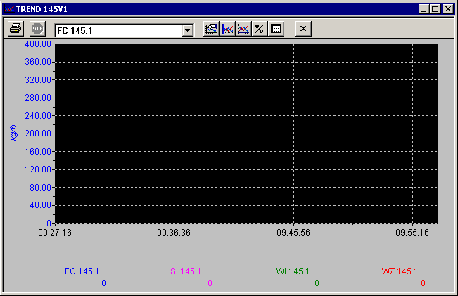

Each trend page is recalled by pushing the corresponding button.

Actual trends display analog values in real time.

The tag name of the analog values appears on the bottom side of the trend.

On the left side of the trend there are limits and unit of measure referred to one of the analog values displayed.

On the bottom side of the trend there is the time base representation showing the start and the end time and date.

## Historical Trends

Historical trend pages are recalled from any section layout pressing the relative button:

TREND_HI

Every trend page is recalled by pushing the corresponding button.

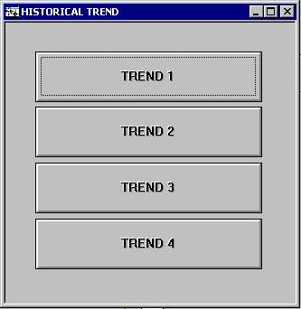

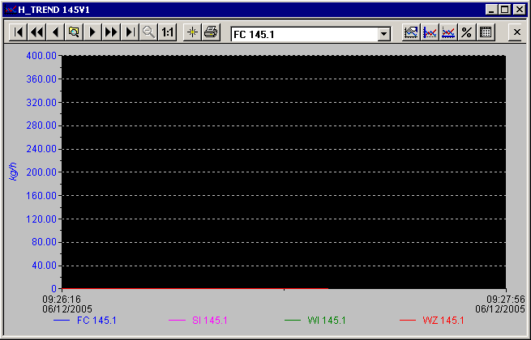

Historical trend displays analog values periodically stored on a file of the hard-disk.

Initial data display is referred to the last interval time stored into the historical file associated to trend; on horizontal trend axis there are date and initial/final time of displayed period.

The tag name of the analog values appears on the bottom of the trend.

On the left side of the trend there are limits and unit of measure referred to one of the analog values displayed.

On the bottom side of the trend there is the time base representation showing the start and the end time and date.

All these data are stored in a dedicated file called D:\HTREND\HTREND.DBF in Excel format. The administrator is able to work on this file with every Excel option. This file can store data for 30 days (one record every minute).

## Batch Archives

NOTE: batch archives are used only for some systems.

Every time a production Batch is completed, LogoView NT archives data of partial weight of charged components for every Dosing Unit.

Every time the chargement of Batch components is completed, a new record is added to archive D:\HBATCH.DBF.

The archive record has the following structure:

DATE\_TIME - REC\_NAME - N\_BATCH - C1\_x - C1\_k….. C2\_x - C2\_k……

C1\_ x is Dosing Unit x value in cycle 1, C2\_x is Dosing Unit x value in cycle 2.

**PAY ATTENTION! It’s very important that Hbatch.dbf never been opened with EXCEL directly, because this could create serious troubles to the system. For that it’s always necessary to do a copy of the file for avoiding to open the original (because EXCEL open the files in exclusive mode and not in share mode).**

## System Utility

With System Utility button from Overview, the operator has access to the system utilities menu; the utilities options are all protected by password, except for Plant report and the totalizers visualization.

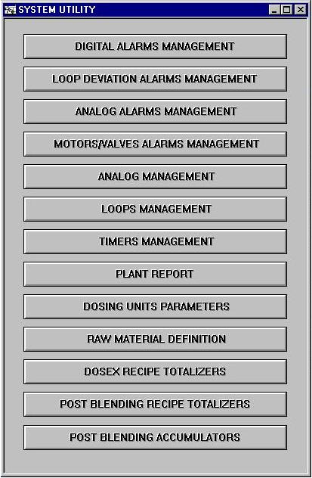

The menu presents a choice window configured as follows:

* **DIGITAL ALARMS MANAGEMENT**
* **LOOP DEVIATION ALARMS MANAGEMENT**
* **ANALOG ALARMS MANAGEMENT**
* **MOTORS/VALVES ALARMS MANAGEMENT**
* **ANALOG MANAGEMENT**
* **LOOPS MANAGEMENT**
* **TIMERS MANAGEMENT**
* **PLANT REPORT**
* **DOSING UNIT PARAMETERS**
* **RAW MATERIAL DEFINITION**
* **DOSEX RECIPE TOTALIZERS**
* **POST BLENDING RECIPE TOTALIZERS**
* **POST BLENDING ACCUMULATORS**

### Digital Alarms Management

In this page it is possible to enable/disable digital alarms and to change alarms string.

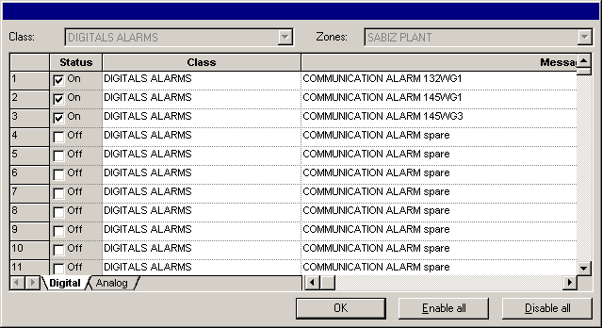

Change alarms description

Disable/enable

Enable all alarms

Disable all alarms

### Loop Deviation Alarms Management

In this page it is possible to enable/disable loop deviation alarms and to change alarms string.

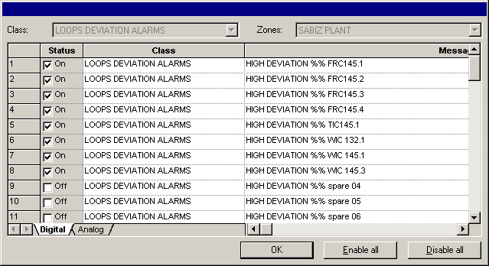

Change alarms description

Disable/enable

Enable all alarms

Disable all alarms

### Analog Alarms Management

In this page it is possible to enable/disable analog alarms and to change alarms string.

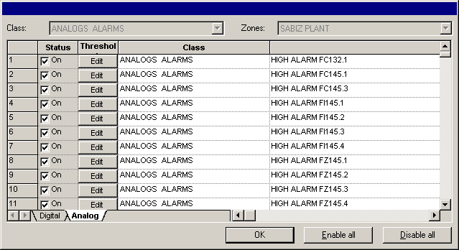

Change alarms description

Disable/enable

Enable all alarms

Disable all alarms

Change alarm thresholds and dead band



Low Low Limit

Low Limit

High Limit

Dead Band

High high Limit

### Motors / Valves Alarms Management

In this page it is possible to enable/disable motors/valves alarms and to change alarms string.

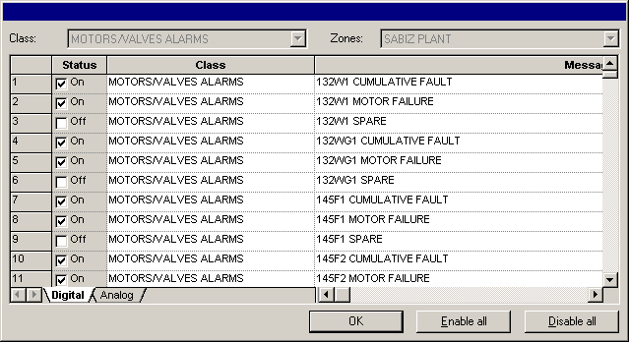

Change alarms description

Disable/enable

Enable all alarms

Disable all alarms

### Analog Management

The function allows to configure plant analog channels.

All parameters displayed are modifiable.

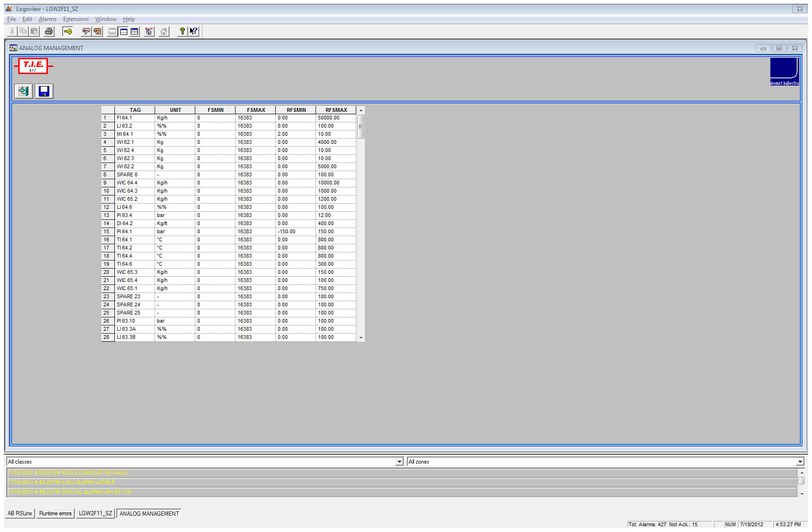

**TAG:**

The operator can change the tag describing the analogic channel, but this change is not reported into the alarm strings and on the static writings inside the screens; it can be only seen into the configuration pages.

**UNIT:**

The operator can modify the measure unit of analogic channels and he will see it modified into the pages of loops and trends.

For a correct visualization, the character "%" must be doubled (“%%”).

**Field full scale Minimum and Maximum Numeric value:**

They are values converted into numeric mode from the PLC and that correspond to minimum and maximum levels of analog input on the PLC card.

**Field full scale Minimum and Maximum Engineering value:**

They are effective values of field full scale of the instrument that correspond to minimum and maximum levels of analogic input.

Single parameter modification is made by positioning the cursor on the value to be changed; the system makes all controls in automatic mode to avoid introduction of non-compatible parameters.

By leaving the procedure or scrolling the page after a not saved modification, a message asks to the operator if he wants to save the modified data or not.

See hardware documentation for connection of displayed analog tags.

### Loops Management

This function allows to associate at the system regulation loops the input and the output variables.

A page reports the loops identified by an initial, the same indicated on the section screens.

All the parameters shown are modifiable.

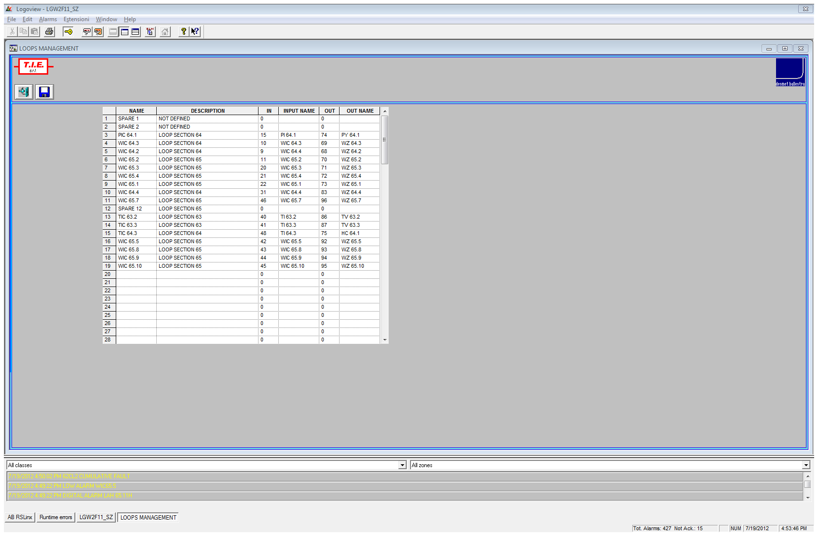

**NAME:**

The operator can change the LOOP tag, but this variation is not reported into the alarm strings, it can be shown only into the configuration pages and into the specific page of Loop visualization.

**DESCRIPTION:**

The operator can change all the descriptions that will show into the specific page of loop visualization.

**IN CHANNEL:**

It’s the number of the loop input analogic channel and it corresponds to the input position into database. Into the nearest box “Input Name” it is shown the corresponding tag.

**OUT CHANNEL:**

It’s the number of the loop output analogic channel and it corresponds to the output position into database. Into the nearest box “Out Name” it is shown the corresponding tag.

By leaving the procedure or scrolling the page after a not saved modification, a message asks to the operator if he wants to save the modified data or not.

### Timers Management

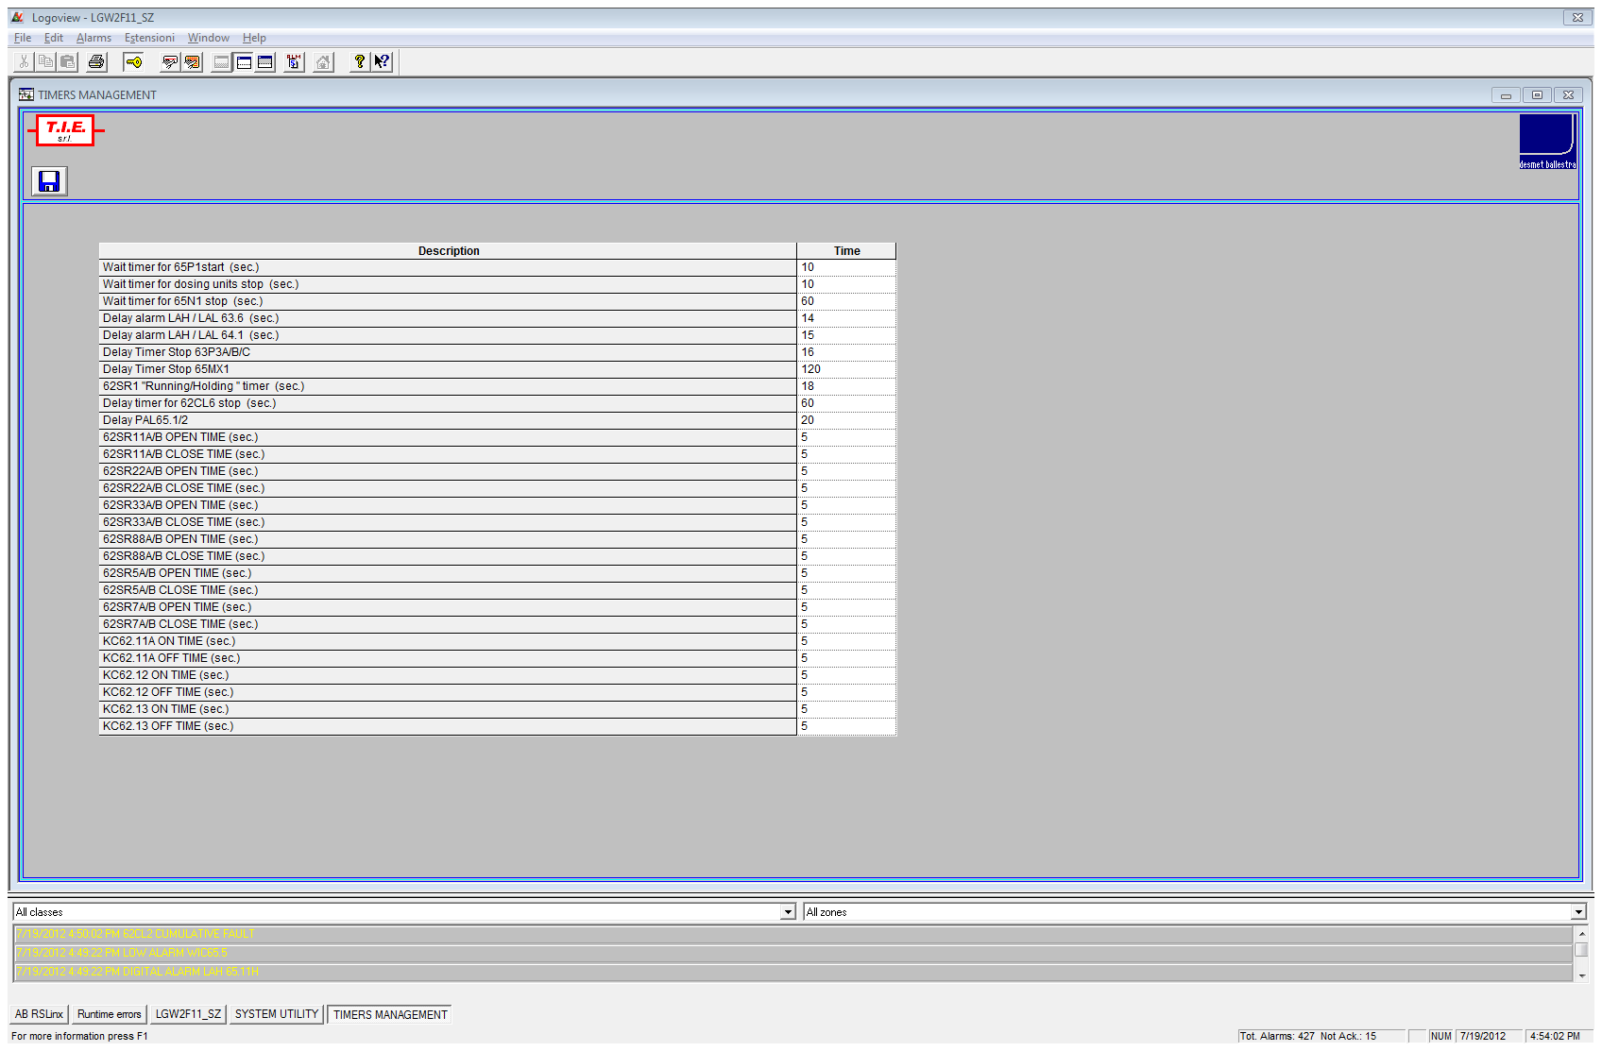

### Plant Report

Push this button in order to print a plant report as shown below.

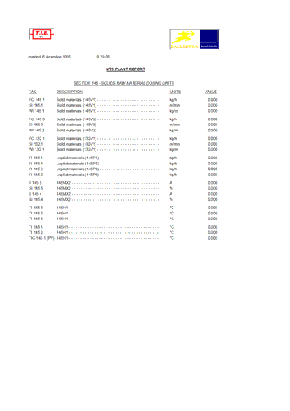

### Dosing Units Paramaters

The **Raw Material Description** correspond to those of the last recipe downloaded.

These data are automatically printed at the end of the production.

To make a print of DOSING UNITS PARAMETERS it’s also available the PRINT button.

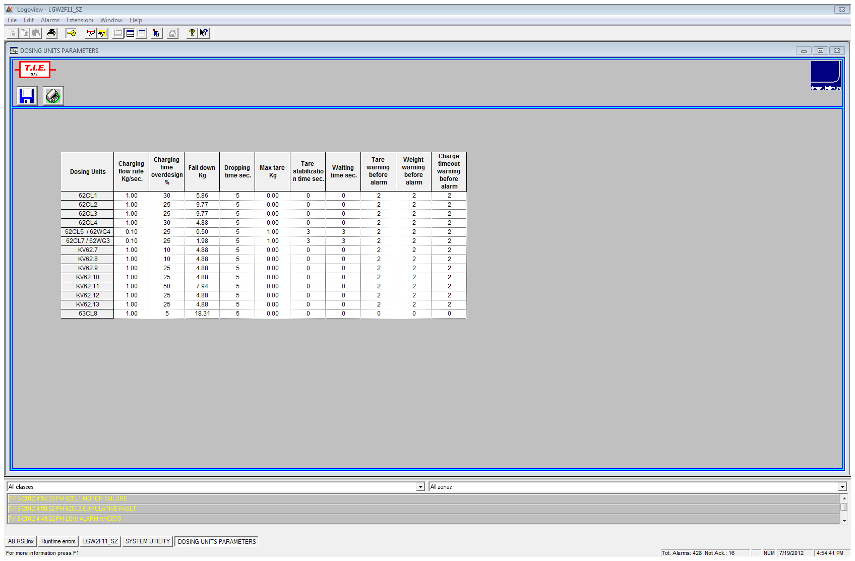

### Raw Material Definition

On this page it’s possible to associate at the 200 possible Raw Material Number (**R.M.I.D.**) the correspondent Raw Material **Code** and **Description**, relevant Molecular Weight (**MW**), **Acid Value** and Concentration (Conc. %), necessary to manage the dosex and the postblend recipes.

For the **RAW MATERIAL DEFINITION** the system uses the Microsoft Excel 2010 tools.

To open the Excel program, the operator needs to click the relevant button named ABS TOTALIZERS in the System Utilities window.

The system automatically points in the folder and open the file: **RAW\_MATERIAL\_DEFINITION.XLS**.

After that, the operator will use Excel instruments for the various functions of file management (opening, saving, print out, etc.).

Please, when to open a Excel file click Yes to update all linked information.

Please, remember do not minimise the Excel files, because the next time you can not open the file. In this case, call your system **administrator**.

In the next page you’ll find a relative example.

**NOTE: the RAW MATERIAL DEFINITION is one only file and the operator must not change the name; the name must ALWAYS be Raw\_Material\_Definition.xls (in this case the file name is very important for the system)**

Data can be modified separately by positioning the mouse into the relative cell and introducing the new value; then you have to confirm it with the ENTER key.

In this page, close to every Raw Material, there is the absolute totalizer.

The absolute totalizer is the total consumption of every material used on the plant.

To read from the PLC the visualized actual value it’s necessary to push the **READ TOTALIZERS** button.

To make the reset of all absolute totalizers it’s available **the RESET TOTALIZERS** button; there is also the chance to reset a single totalizer pushing on its own **RESET** button just near it.

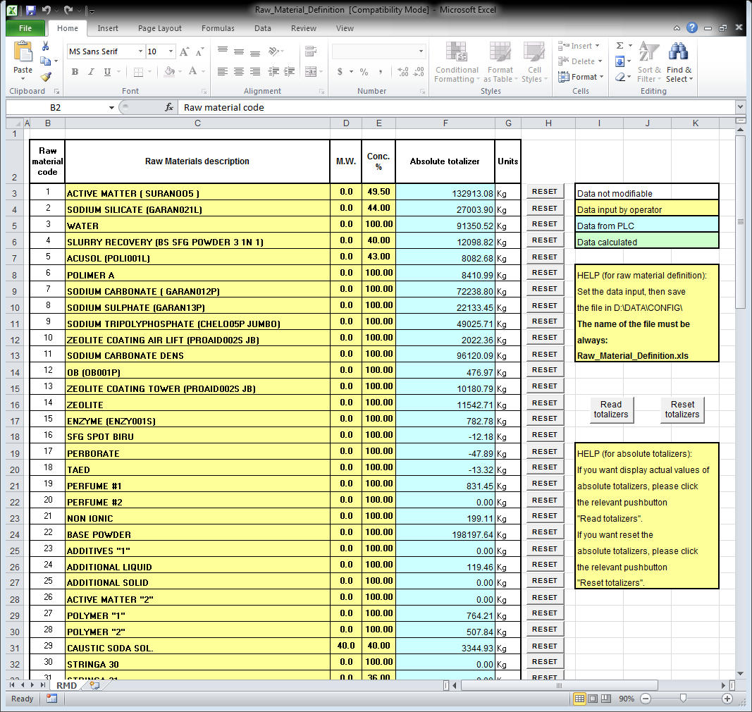

### Dosex Recipe Totalizer

On this page it’s possible to view the actual dosex recipe totalizers.

The Raw Material **I.D.**, the Raw Material **Code** and the Raw Material **Description** correspond to those of the last recipe downloaded.

These data are automatically printed at the end of the production.

To make a print of DOSEX RECIPE TOTALIZERS it’s also available the **PRINT** button.

With the next production Raw Material I.D., Code and Description will be replaced (with items of the new recipe downloaded) and so the totalizers will be reset.

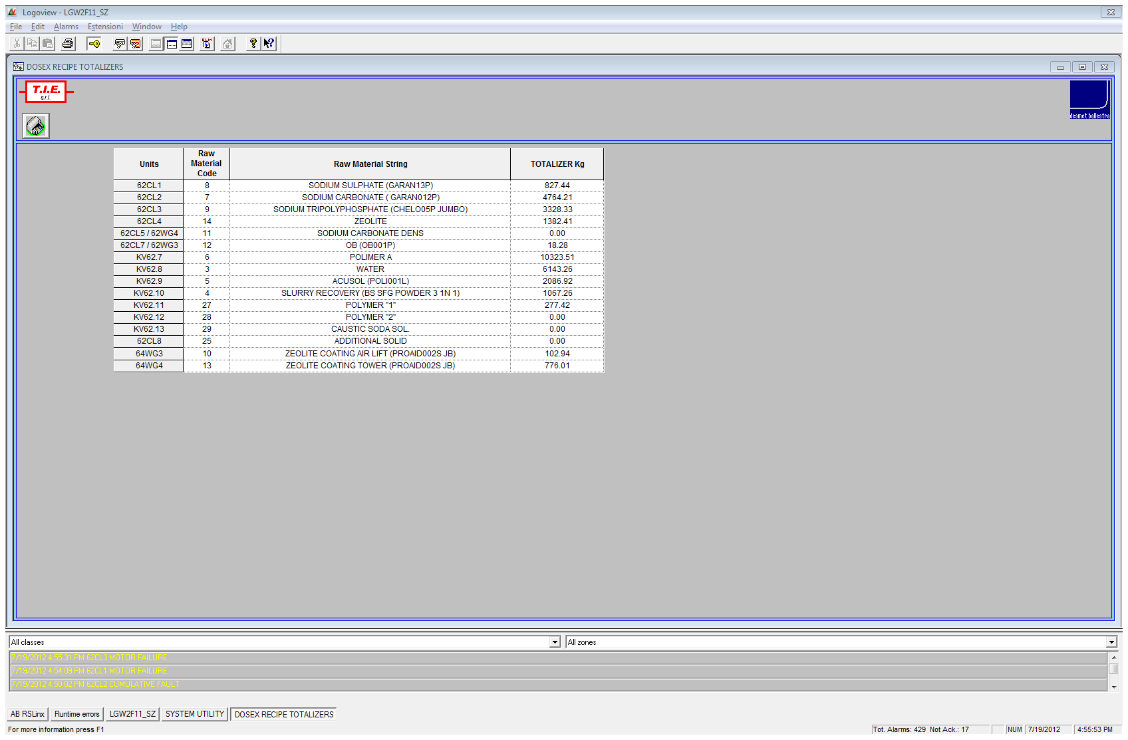

### PB Recipe Totalizer

On this page it’s possible to view the actual post blending recipe totalizers.

The Raw Material **I.D.**, the Raw Material **CODE** and the Raw Material **Description** correspond to those of the last recipe downloaded.

These data are automatically printed at the end of the production.

To make a print of POST BLENDING RECIPE TOTALIZERS it’s also available the **PRINT** button.

With the next production Raw Material I.D, Code and Description will be replaced (with items of the new recipe downloaded) and so the totalizers will be reset.

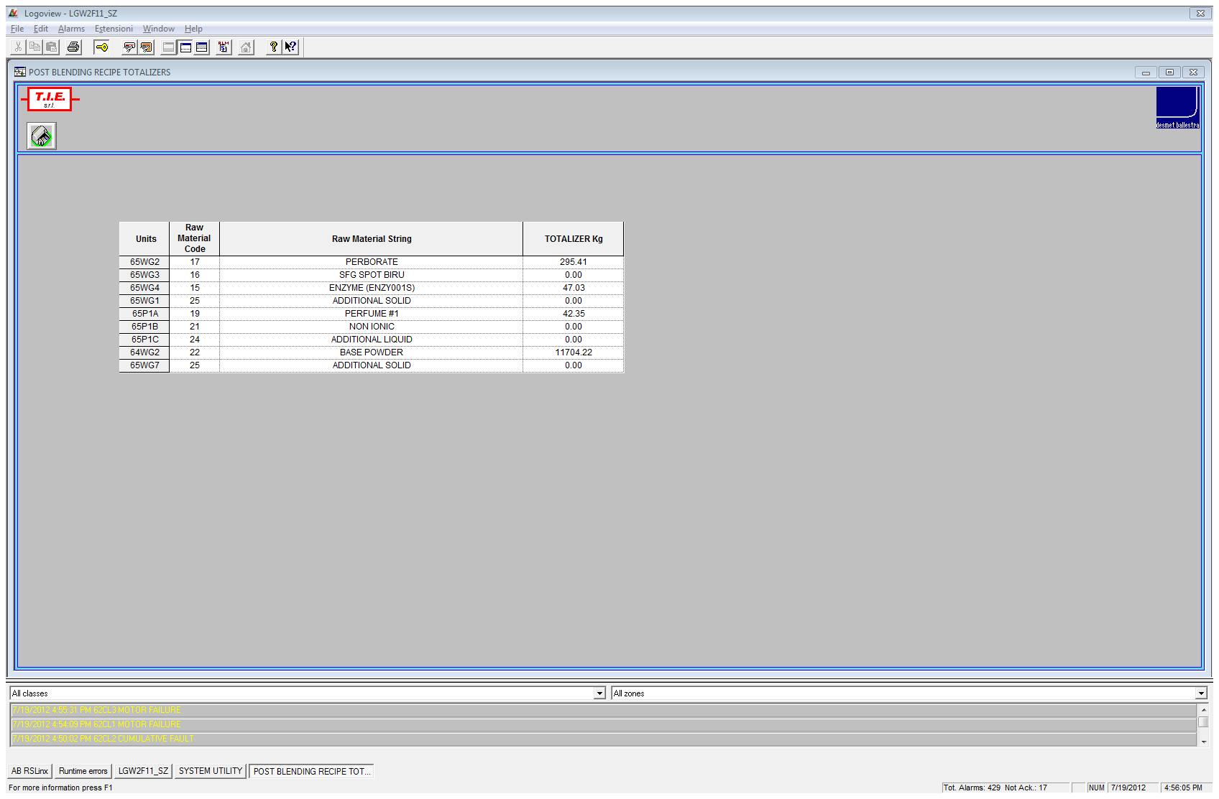

## Recipe

For managing the recipes, the system uses the Microsoft Excel tools.

To open the Excel program click the relevant button named RECIPE in the screen layout.

The system automatically points in the PC Folder (“D:\DATA\2F11\RECIPE”). If the system does not point in this folder, call your system **administrator**.

After that, the operator will use Excel instruments for the various functions of file management (opening, saving, print, etc.); it is understood that once the recipe file has been opened for setting the production required, the operator will be guided and controlled for avoiding any kind of error (range limits, calculated values control, automatic raw materials names, etc.).

Please, opening a Excel file, always click Yes to update all linked information.

All data are however checked by the system, and when all is OK, the operator can download the recipe clicking the corresponding button, into Excel page.

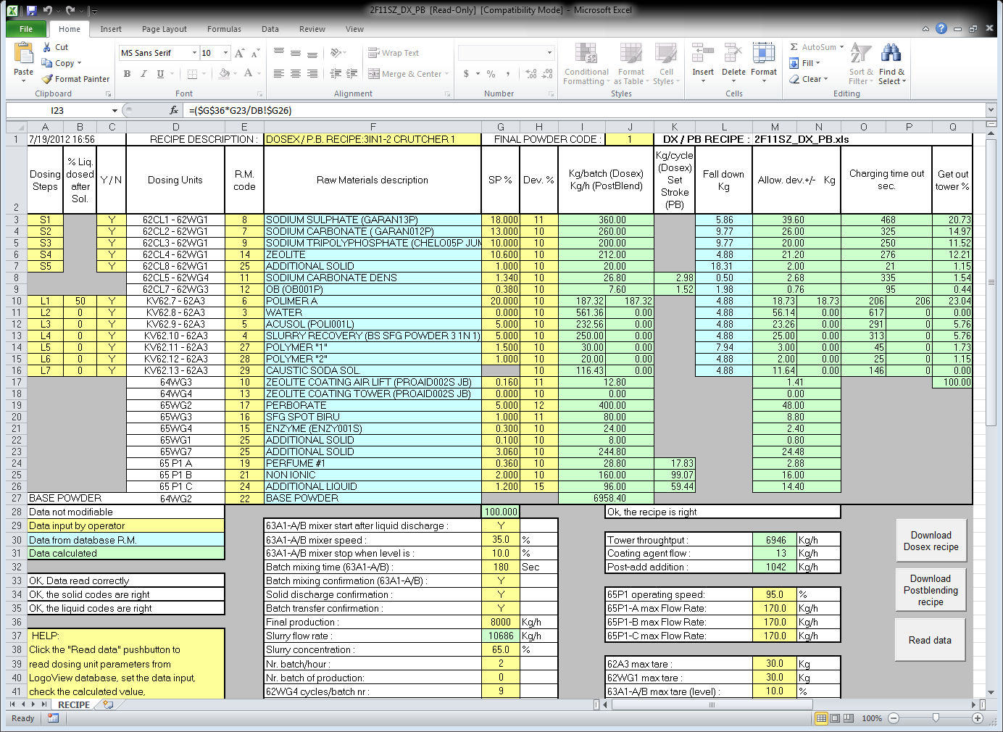

## Hardcopy

It is possible to get hardcopies of video pages by pressing “CTRL-P” and then the “Print” button; now you have to select “A4 (210 x 297 mm.)” in Setup/Paper Options, and “Landscape” in Features.

# Index Of Contents

[1 General Concepts 2](#_Toc330480347)

[2 First Part 3](#_Toc330480348)

[2.1 System architecture and general concepts 3](#_Toc330480349)

[2.2 Hardware/software technical features of PCs 5](#_Toc330480350)

[2.3 Data Organization 6](#_Toc330480351)

[2.3.1 Data Type “A” 6](#_Toc330480352)

[2.3.2 Data Type “B” 6](#_Toc330480353)

[2.3.3 Data Type “C” 7](#_Toc330480354)

[2.3.4 Data Type “D” 7](#_Toc330480355)

[Folder Definition On The Pc 8](#_Toc330480356)

[2.4 Management Of Production Files 9](#_Toc330480357)

[3 Second Part 10](#_Toc330480358)

[3.1 System Functions 10](#_Toc330480359)

[3.2 Startup Procedure 10](#_Toc330480360)

[3.3 Shutdown Procedure 11](#_Toc330480361)

[4 Application 11](#_Toc330480362)

[4.1 Overview 12](#_Toc330480363)

[4.2 Password Management 14](#_Toc330480364)

[4.3 Monitoring Sections 15](#_Toc330480365)

[4.3.1 Section 61 / 1 17](#_Toc330480366)

[4.3.2 Section 61 / 2 18](#_Toc330480367)

[4.3.3 Section 62 / 1 19](#_Toc330480368)

[4.3.4 Section 62 / 2 20](#_Toc330480369)

[4.3.5 Section 63 / 1 21](#_Toc330480370)

[4.3.6 Section 63 / 2 22](#_Toc330480371)

[4.3.7 Section 64 / 1 23](#_Toc330480372)

[4.3.8 Section 64 / 2 24](#_Toc330480373)

[4.3.9 Section 65 / 1 25](#_Toc330480374)

[4.3.10 Section 65 / 2 26](#_Toc330480375)

[4.4 Manual Commands 27](#_Toc330480376)

[4.5 Control Loops Management 28](#_Toc330480377)

[4.5.1 Loop Window 29](#_Toc330480378)

[4.5.2 Loop Setup Window 30](#_Toc330480379)

[4.5.3 Loop Trend Window 31](#_Toc330480380)

[4.6 Alarms Management 32](#_Toc330480381)

[4.8 Historical Alarms Management 34](#_Toc330480382)

[4.9 Actual trends 36](#_Toc330480383)

[4.10 Historical Trends 38](#_Toc330480384)

[4.11 Batch Archives 40](#_Toc330480385)

[4.12 System Utility 41](#_Toc330480386)

[4.12.1 Digital Alarms Management 42](#_Toc330480387)

[4.12.2 Loop Deviation Alarms Management 43](#_Toc330480388)

[4.12.3 Analog Alarms Management 44](#_Toc330480389)

[4.12.4 Motors / Valves Alarms Management 45](#_Toc330480390)

[4.12.5 Analog Management 46](#_Toc330480391)

[4.12.6 Loops Management 48](#_Toc330480392)

[4.12.7 Timers Management 49](#_Toc330480393)

[4.12.8 Plant Report 50](#_Toc330480394)

[4.12.9 Dosing Units Paramaters 51](#_Toc330480395)

[4.12.10 Raw Material Definition 52](#_Toc330480396)

[4.12.11 Dosex Recipe Totalizer 54](#_Toc330480397)

[4.12.12 PB Recipe Totalizer 55](#_Toc330480398)

[4.13 Recipe 56](#_Toc330480399)

[4.14 Hardcopy 57](#_Toc330480400)

[5 Index Of Contents 58](#_Toc330480401)